Grove - Touch Sensor

(Redirected from [Twig - Touch Sensor](http://www.seeedstudio.com/wiki/index.php?title=Twig_-_Touch_Sensor&redirect=no))

|  |
| --- |
| **Contents**   [[hide](javascript:toggleToc())]   * [1 Introduction](http://www.seeedstudio.com/wiki/index.php?title=Twig_-_Touch_Sensor#Introduction) * [2 Features](http://www.seeedstudio.com/wiki/index.php?title=Twig_-_Touch_Sensor#Features) * [3 Applications Ideas](http://www.seeedstudio.com/wiki/index.php?title=Twig_-_Touch_Sensor#Applications_Ideas) * [4 Specifications](http://www.seeedstudio.com/wiki/index.php?title=Twig_-_Touch_Sensor#Specifications)   + [4.1 Key Specification](http://www.seeedstudio.com/wiki/index.php?title=Twig_-_Touch_Sensor#Key_Specification)   + [4.2 Electronic Characterstics](http://www.seeedstudio.com/wiki/index.php?title=Twig_-_Touch_Sensor#Electronic_Characterstics) * [5 Usage](http://www.seeedstudio.com/wiki/index.php?title=Twig_-_Touch_Sensor#Usage) * [6 Version Tracker](http://www.seeedstudio.com/wiki/index.php?title=Twig_-_Touch_Sensor#Version_Tracker) * [7 Resources](http://www.seeedstudio.com/wiki/index.php?title=Twig_-_Touch_Sensor#Resources) |

Introduction

It’s time to replace a traditional push button with the touch sensor module. It uses the TTP223-B touch detector IC to measure the capacitance of a metallic pad. It can detect the change in capacitance when a finger is near it. The TTP223 has Fast/Low Power modes for your selection, and the TTP223-B is set as Low Power mode by default. When detecting a key touch, it will switch to Fast mode. After the key touch is released there will be about 12 seconds until it returns to Low Power mode, which helps saving the power. You can even place the metallic pad under a non-metallic surface such as a plastic or glass sheet and it will still work as a button. This may be useful for projects that need to be waterproof. You can also make a secret button by placing it inconspicuously behind a smooth surface. For instance you could place them under a nonmetallic card table and by casually pressing the right location on a tabletop surface you could mysteriously control your DIY project.

Model:[SEN11303P](http://www.seeedstudio.com/depot/grove-touch-sensor-p-747.html?cPath=156_160)

[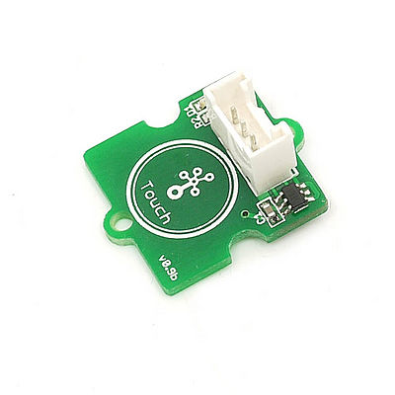](http://www.seeedstudio.com/wiki/File:Twig-Touch.jpg)

Features

* Grove compatible interface
* 2.0-5.5V DC supply
* Low latency response
* Low power consumption
* 2.0cm x 2.0cm Grove module
* Power indicator led

Applications Ideas

* Inconspicuous button
* Water proof electric product
* Button key replacement

Specifications

**Key Specification**

|  |  |
| --- | --- |
| **Items** | **Min** |
| PCB Size | 2.0cm*2.0cm |
| Interface | 2.0mm pitch pin header |
| IO Structure | SIG,VCC,GND,NC |
| ROHS | YES |

**Electronic Characterstics**

|  |  |  |  |  |  |
| --- | --- | --- | --- | --- | --- |
| **Items** | **Conditions** | **Min** | **Norm** | **Max** | **Unit** |
| VCC | - | 2.0 | 3.0 | 5.5 | Volts |
| Operating Current | Vcc=3V, at low power mode and output no load | - | 1.5 | 3.0 | μA |
| VDD=3V at fast mode and output no load | - | 3.5 | 7.0 | μA |
| Output Port Sink Current(IOL) | VDD=3V, VOL =0.6V | - | 8 | - | mA |
| Output Port Source Current (IOH) | VDD=3V, VOH =2.4V | - | -4 | - | mA |
| Output Response Time | VDD=3V, At fast mode | - | - | 60 | mS |
| VDD=3V, At low power mode | - | - | 220 | mS |

Usage

1. Plug this module and a Grove – LED to the Grove Base Shield using the 4 pin cable. You can use any of the digital pins. If you use your finger to touch the electrode of the module, it will output a High level, else it sends LOW. So you can use it as a touch switch or so. For more information please consult the[TTP223 specification](http://garden.seeedstudio.com/images/d/d5/TTP223.pdf).  
2. Plug it onto the Arduino/Seeeduino. Connect the board to PC using USB cable. 3. Copy the demo code to your sketch, then upload to Arudino or Seeeduino board. Please click [here](http://www.seeedstudio.com/wiki/Upload_Code) if you do not know how to upload.

The following sketch demonstrates a simple application of controlling the led by the Touch sensor. When you touch the electrode using your finger, the led will light up. **Hardware connection as shown below：**   
[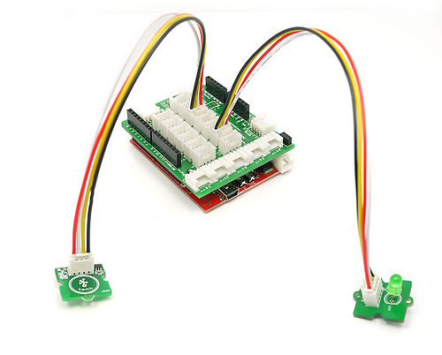](http://www.seeedstudio.com/wiki/File:Touch_LED.jpg)  
**Demo Code:**

**const** **int** TouchPin=9;

**const** **int** ledPin=12;

**void** **setup**() {

pinMode(TouchPin, **INPUT**);

pinMode(ledPin,**OUTPUT**);

}

**void** **loop**() {

**int** sensorValue = digitalRead(TouchPin);

**if**(sensorValue==1)

{

digitalWrite(ledPin,**HIGH**);

}

**else**

{

digitalWrite(ledPin,**LOW**);

}

}

The output result should be :The led light while Grove - Touch Sensor is touched.

Version Tracker

|  |  |  |
| --- | --- | --- |
| **Revision** | **Descriptions** | **Release** |
| [Electronic brick-Touch Sensor module](http://www.seeedstudio.com/wiki/Electronic_brick-Touch_Sensor_module) | Initial public release | Jan 18, 2010 |
| Grove - Touch Sensor v1.0 | change revision from Electronic brick to GROVE Unit | Jan 13, 2011 |

Resources

* [Eagle Files](http://garden.seeedstudio.com/images/8/87/Touch_sensor.zip)
* [TTP223pdf](http://garden.seeedstudio.com/images/d/d5/TTP223.pdf)